**Exercícios Normalização**

1. Normalize até a 3FN os seguintes dados:

vendedor (nro_vend, nome_vend, sexo_vend, {nro_cli, nome_cli, end_cli, data_atend } )

R.: As seguintes dependências funcionais devem ser garantidas na normalização:

nro_vend → nome_vend, sexo_vend

nro_cli → nome_cli, end_cli

nro_vend , nro_cli → data_atend

|  |
| --- |
| vendedor_3FN |

|  |  |  |  |
| --- | --- | --- | --- |
| PK | nro_vend | nome_vend | sexo_vend |
|  | Num | Char | Char |

|  |
| --- |
| cliente_3FN |

|  |  |  |  |
| --- | --- | --- | --- |
| PK | nro_cli | nome_cli | end_cli |
|  | Num | Char | Num |

|  |
| --- |
| Nro_vend_3FN |

|  |  |  |
| --- | --- | --- |
| PK | nro_cli | data_vend |
|  | Num | Char |

1. Normalize até a 3FN:

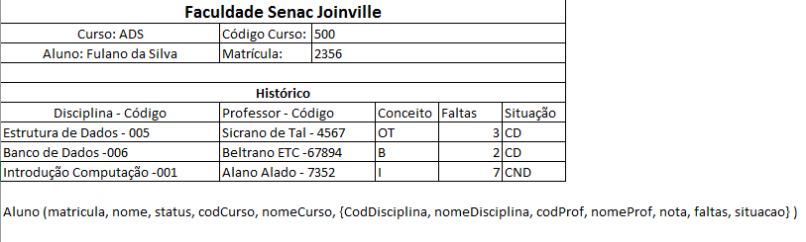

R.: .

CodCurso -> nomeCurso

CodDisciplina -> nomeDisciplina

codDisciplina, CodCurso -> CodProf

CodAluno -> (nome, blablabla)

CodProf -> nomeProf

CodAluno,Matricula -> dtInicio

Matricula -> CodCurso

codDisciplina, matricula, codcurso -> nota, faltas, situação

|  |
| --- |
| Curso_3FN |

|  |  |  |
| --- | --- | --- |
| PK | CodCurso | NomeCurso |
|  | Num | Char |

|  |
| --- |
| Disciplina_3FN |

|  |  |  |
| --- | --- | --- |
| PK | CodDisciplina | NomeDisciplina |
|  | Num | Char |

|  |
| --- |
| Disciplina_Curso_3FN |

|  |  |  |  |
| --- | --- | --- | --- |
| PK | CodDisciplina | CodCurso | CodProf |
|  | Num | Char | Num |

|  |
| --- |
| Aluno_3FN |

|  |  |  |  |  |
| --- | --- | --- | --- | --- |
| PK | CodAluno | NomeAluno | IdadeAluno | SexoAluno |
|  | Num | Char | Num | Char |

|  |
| --- |
| Professor_3FN |

|  |  |  |
| --- | --- | --- |
| PK | CodProf | NomeProfessor |
|  | Num | Char |

|  |
| --- |
| Matricula_Aluno_3FN |

|  |  |  |  |
| --- | --- | --- | --- |
| PK | CodAluno | Matricula | dtInicio |
|  | Num | Num | Num |

|  |
| --- |
| Matricula_3FN |

|  |  |  |
| --- | --- | --- |
| PK | Matricula | CodCurso |
|  | Num | Num |

|  |
| --- |
| frequencia_3FN |

|  |  |  |  |  |  |  |
| --- | --- | --- | --- | --- | --- | --- |
| PK | CodDisciplina | Matricula | CodCurso | nota | faltas | situacao |
|  | Num | Num | Num | Num | Num | Char |